# Brightness

The first step in the image processing is to increase the brightness of the image in order to fade out background elements to make foreground objects stand out. Below is a comparison of the before and after brightness adjustment, as well as their associated histograms.

The following examples used an alpha value of 2 and a beta value of 128, experimentally chosen to provide good tracking performance.

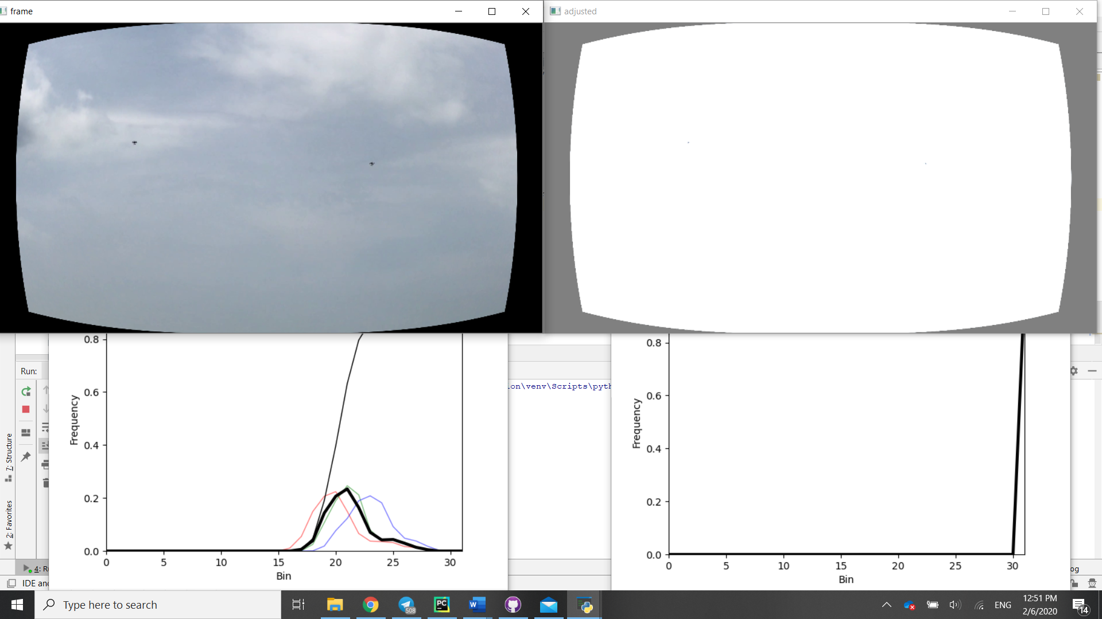

With only the sky in frame, the entire output image is white. However, the background subtractor is still able to identify the drones as foreground objects. This is possibly due to their motion being enough to allow the faint, relatively darker spots to stand out on the completely white background.

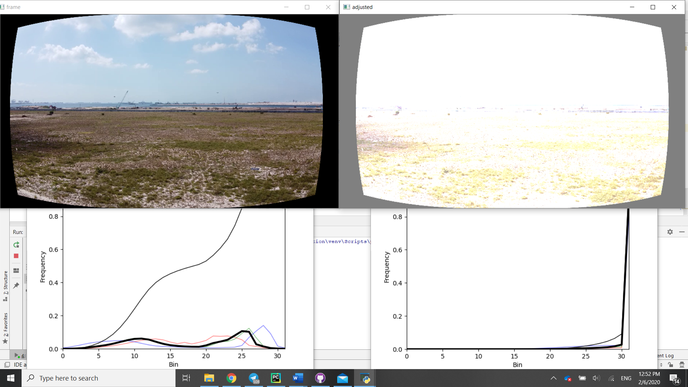

With the horizon, along with the sky and ground in frame, the sky has once again been completely removed, whereas the ground is highly oversaturated. This oversaturation allows for objects near the horizon to sometimes be detected.

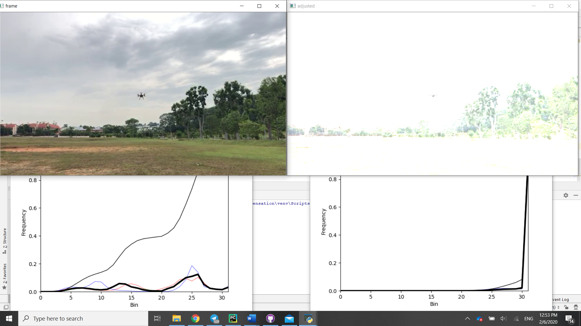

This video has a lower resolution than the previous two, as well as having the drone closer to the camera. As a result of the brightness adjustment, the legs of the drone are whited out, and the propellers are regarded as separate objects, which results in multiple detections of the same drone.

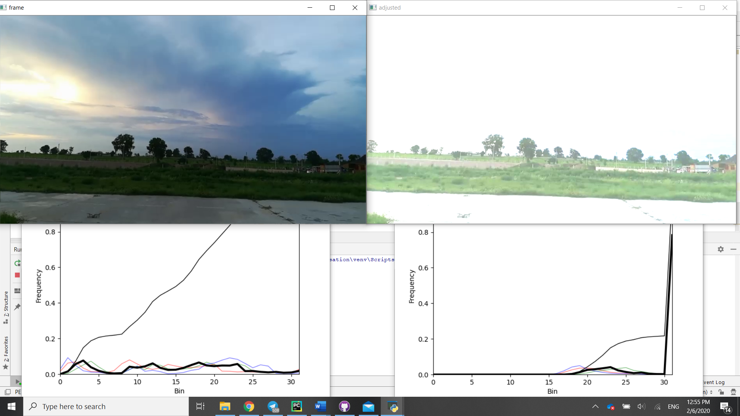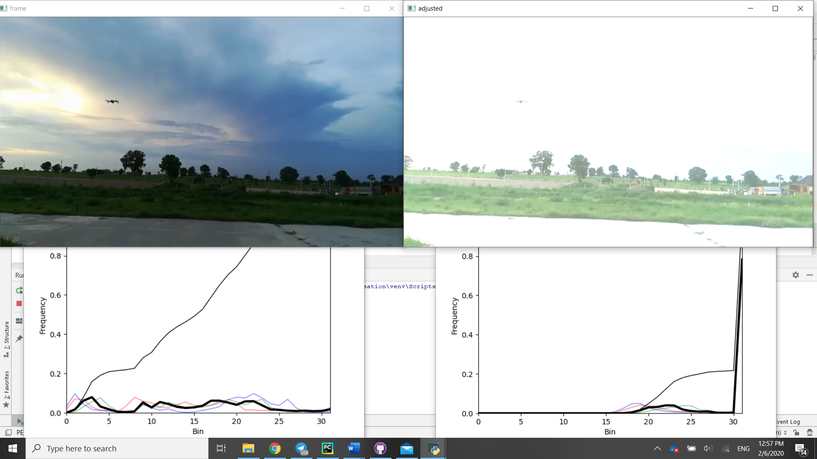

Detections towards the start of this relatively darker video suggest that the brightness adjustment chosen is suitable, with whole drone being identified as a single object versus the last scene at a similar distance and resolution. However, the issue of poor detections near the tree top level becomes clear in the later half of the video, with occlusion by the dark clouds also posing a challenge as these background objects have not been successfully hidden by the brightness increase.

Although somewhat counter intuitive, the results from these examples suggest that in order to improve detection near background objects, the frame should be oversaturated to the point where even the drones are barely visible. Depending on light levels in the frame, more or less brightness may be required.

The challenge remains to determine the optimal brightness adjustment based on information available from the frame, in other to remove the need for experimental selection of the best values which can be time consuming and unable to be implemented in real time.

To do so, one could look at the histograms of the image, which show the distribution of frames with different brightness levels. Notable features include the number of local maxima, the location of local maxima as well as the range of brightness values which are unused.

# Thresholding

An alternate or extra step to brightness adjustment is thresholding. In a similar vein, it identifies the sky as pixels above a certain brightness. Below is a sampling of thresholding in the rgb channels at a value 127 for all channels. Different threshold values could be chosen for each channel to better identify the sky and perhaps greenery. Eg. High blue values correspond to the sky, while trees have relatively higher green values, so a higher threshold could be chosen for them. The problem with trees is that they are generally quite dark and will be difficult to threshold effectively.

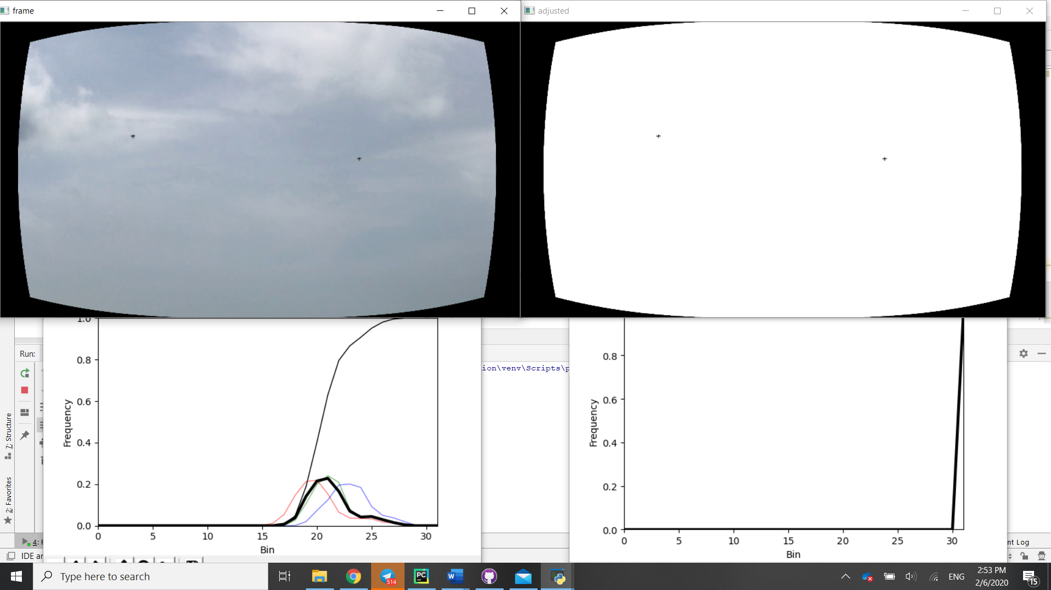

With only the sky as the background, the drones standout very clearly as they are unaffected by the operation. Compare to the brightness increase where they are also whited out.

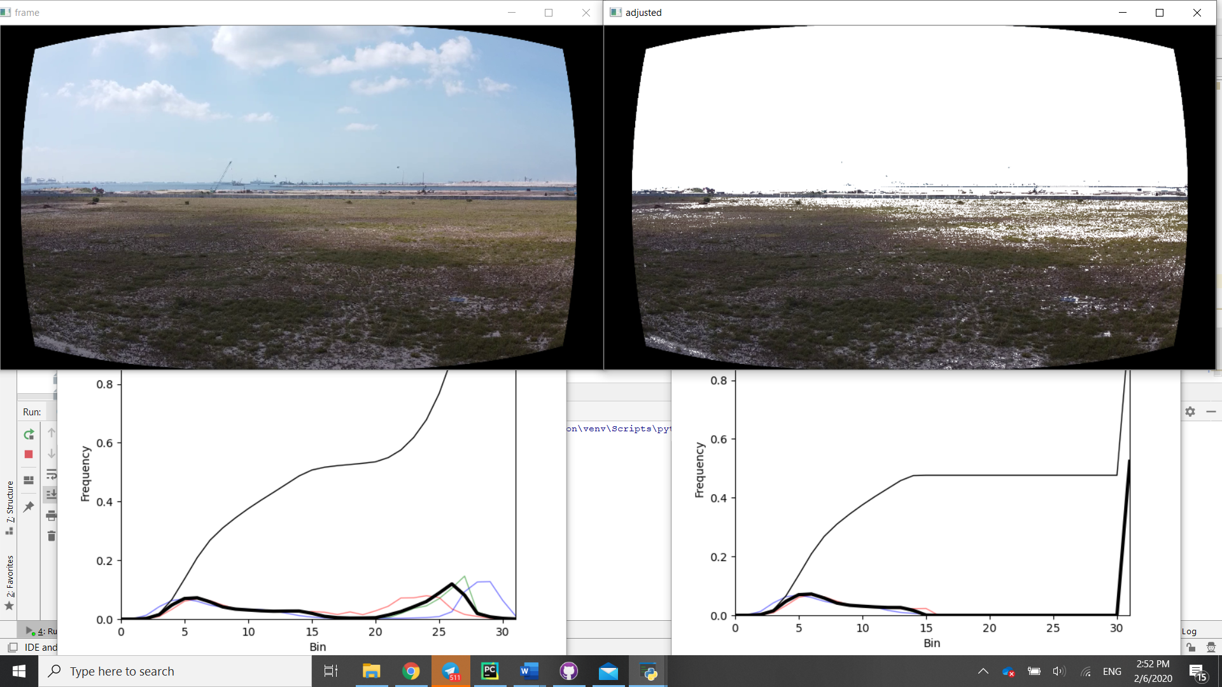

The sky is again completely white, while the horizon is partially erased, and the ground erased in parts. Performance is worse than brightness adjustment (crane is detected, stationary drone is not).

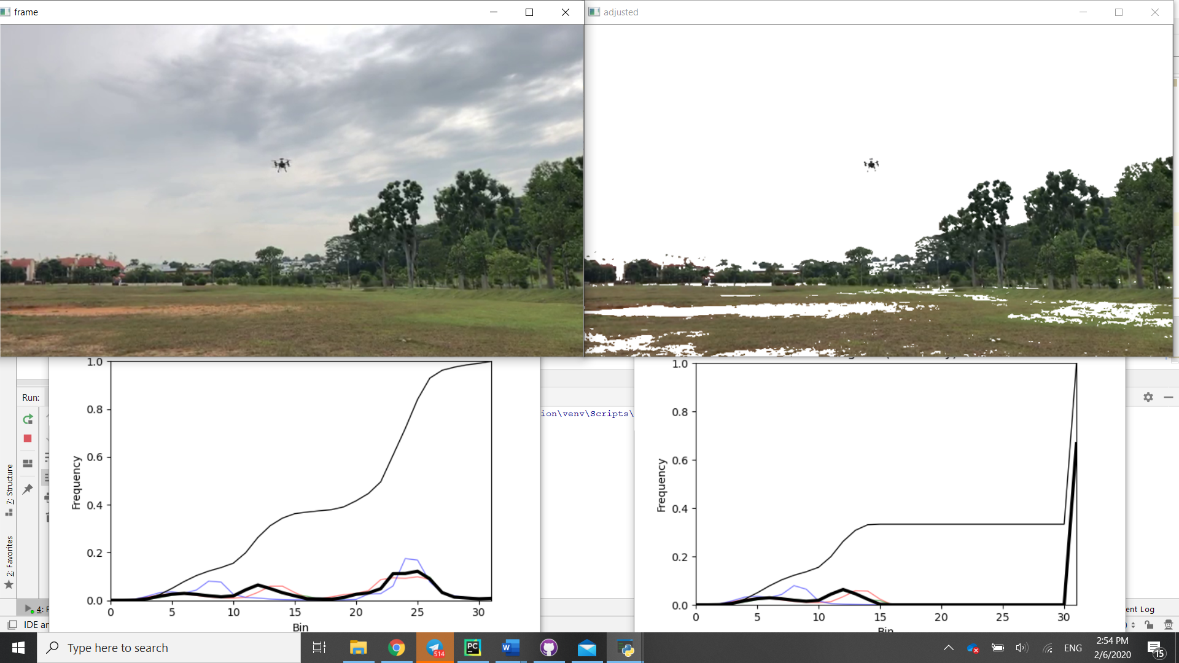

The sky is completely removed, with the ground removed in parts which are brown. (High red values perhaps? Notice the red roofs are missing too). Performance is better than brightness adjustment (No other detections)

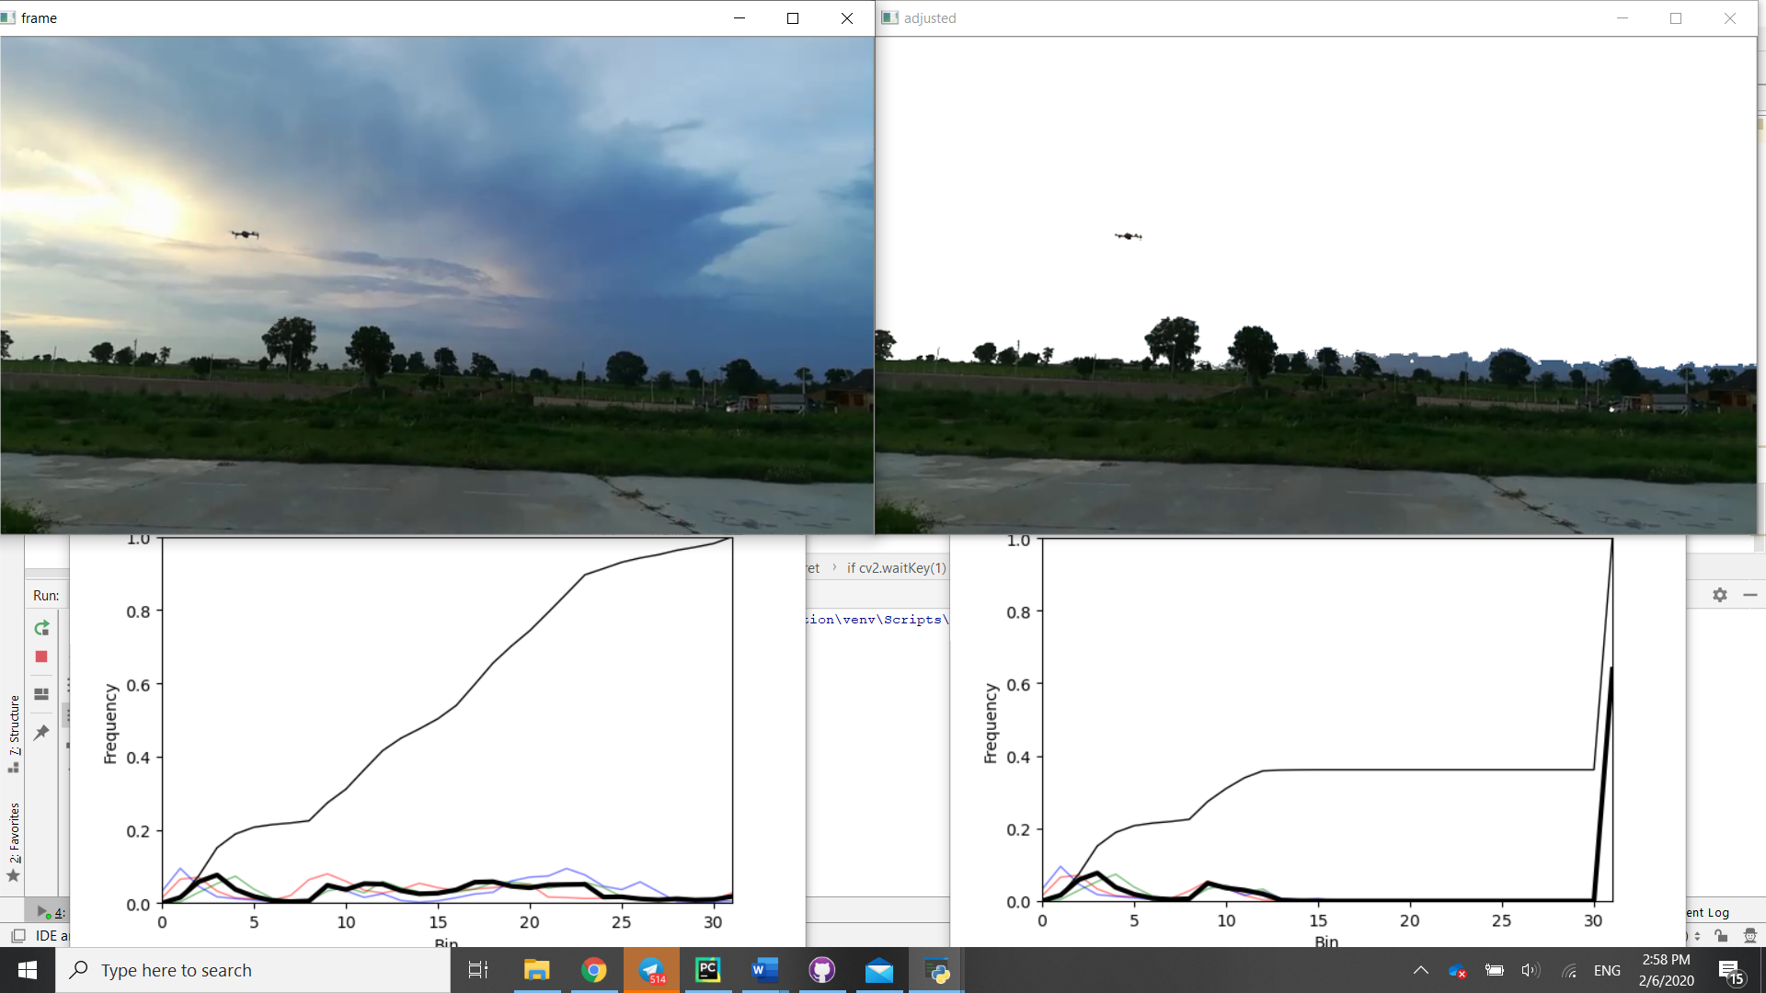

Finally, in the darker scene, the sky has not been completely removed in the darker parts of the horizon. What this implies is that different threshold values need to be chosen depending on the scene, or the brightness needs to be adjusted before the thresholding operation.